**F.4 Biology Ch.11 Transport of substances and Support in Plants**

Name: _________________________( ) F. 4 ______ Date: ________________________

**Video task sheet**

**Title: Studying the transpiration rate of a leafy shoot using a bubble potometer**

**1. Objective**: To find out the transpiration rate of a leafy shoot using a bubble photometer.

1. **Principle:**

A bubble potometer is an apparatus used to measure the rate of water uptake by a cut shoot or young seedlings, by measuring the rate at which an air bubble moves along a capillary tube. Actually, it does not measure the transpiration rate directly, but since most of the water taken up is lost by **transpiration**, with the **assumption** that rate of water uptake equals to the rate of water loss, the rate of movement of the air bubble can be used to represent the approximate transpiration rate of the plant.

Transpiration from the plant surface is mainly due to two physical processes, evaporation and diffusion, therefore any change in the environment affecting the rates of these two processes will also affect the rate of transpiration. In addition, transpiration mainly takes place through stomata, the size of stomata, which is in term affected by the environmental conditions will also affect the transpiration rate. Therefore the transpiration rates of a leafy shoot under different environmental conditions can be measured and compared using a bubble potometer.

Graduated capillary tube

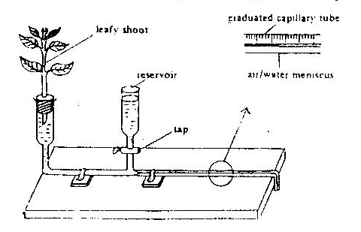

Leafy shoot

1. **Set-up**

Water meniscus

reservoir

1. **Results**

Distance moved by the bubble = ____________cm

Time taken = ___________ min

Rate of movement of air bubble = ______________________________________________

Rate of transpiration **in terms of** bubble movement = _______________________________

1. **Discussion**
2. **Explain the movement of air bubble in the capillary tube**.

As water is lost from the leaves, a pulling force known as transpiration pull is set up. This force draws water up the xylem vessels of the stem, inducing water absorption. When water is absorbed by the leafy shoot, the air bubble is moved towards the plant.

(ii) **State three necessary *precautions* in setting up the potometer**.

- The leafy shoot should be cut and fitted into the potometer under water

to prevent air from entering the xylem vessels and block the upward movement of water.

- All junctions should be air tight or sealed with vaseline to prevent leakage.

- The bubble introduced should be small to prevent movement of it being slowed down / breakage of the continuous water column.

(iii) It is **not necessary to add a layer of oil on the surface of water inside the reservoir** because the water in the reservoir is used to refill the capillary tube and move the bubble to the starting point. Any water evaporation does not affect the movement of the air bubble.

(iv) State four **environmental factors** that may affect the rate of transpiration of a plant.

|  |
| --- |
| Light intensity, humidity, wind speed, temperature |

(v) Under what conditions will the bubble potometer fail to measure the transpiration rate accurately?

- If a dehydrated leafy shoot is used, the rate of water absorption will be higher than transpiration rate.

- Under dry and windy conditions, the transpiration rate of the plant may exceed its rate of water absorption

1. **Conclusion:**

The transpiration rate of the leafy shoot in terms of the rate of bubble movement was ________________________.

**…………………………………………………………………………………………………………………….**

**Title: Studying the transpiration rate of a leafy shoot using a weight potometer**

1. **Objective**: To find out the rate of water uptake and the rate of water loss

of a leafy shoot using a weight potometer

1. **Principle:**

A weight potometer is an apparatus used to measure the rate of transpiration of a cut shoot or young seedlings. The volume of water loss from the plant can be obtained by measuring the change in weight of the whole set-up. The rate of transpiration can then be measured by calculating the volume of water loss per unit time.

In this investigation, the volume of water absorbed by the plant can also be found by measuring the change in water level in the burette of the set-up. The rate of water loss and rate of transpiration can then be compared.

1. 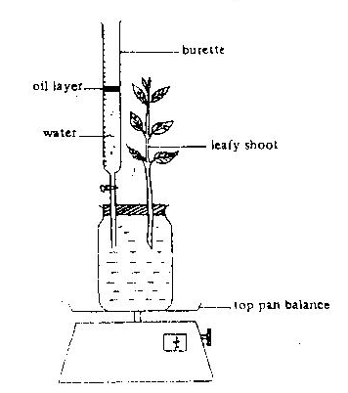**Procedure:**

Oil layer

burette

(i) Cut a leafy shoot from a plant under water and fitted the shoot

into the weight photometer under water as shown in the following diagram.

water

Leafy shoot

(ii) Put a layer of oil on the water surface in the burette.

(iii) Note down the initial water level in the burette and

the weight of the whole apparatus

(iv) After one hour, record the water level and the weight of

Top pan balance

the whole apparatus again

***Precautions:***

- Make sure that the leafy shoot and the wall of the apparatus are dry.

- Cut the leafy shoot under water.

- Fit the leafy shoot into the weight potometer under water

- All junctions should be air tight or sealed with vaseline to prevent leakage.

[refer to the precautions for the bubble photometer for the reason behind each precaution]

1. **Results**

Title: _______________________________________________________________

|  |  |  |
| --- | --- | --- |
|  | Water level in the burette (cm3) | Weight of the whole set-up (g) |
| At the start | V1 |  |
| After the experiment | V2 |  |

Rate of water uptake =

Rate of transpiration =

1. **Discussion**

(i) Compare the volume of water loss and water uptake of the leafy shoot. Give an explanation for such difference.

The volume of water uptake is slightly greater than the volume of water loss.

This is because not all water absorbed by a plant is transpired or lost. A certain amount of water is retained by the plant for photosynthesis and plant growth etc.

(ii) Why is it necessary to add a layer of oil on the water surface in the burette?

To reduce water evaporation from the burette which may cause an overestimation on the amount of water uptake and amount of water transpired.

(iii) Compare the use of weight potometer and the bubble potometer to measure the rate of transpiration, which method is better? Explain your answer.

The weight potometer is more accurate.

Because the weight potometer can measure the transpiration rate of a leafy shoot directly, but the bubble potometer can only measure rate of water uptake of the leafy shoot.

|  |
| --- |
| 1. **Conclusion:** The rate of transpiration of the leafy shoot is |